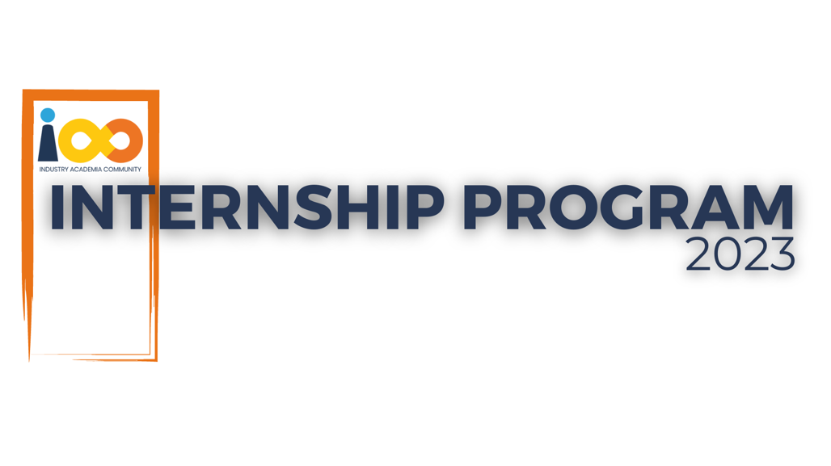

PROJECT REPORT

PYTHON  
  
Student Intern Insights

|  |  |  |  |
| --- | --- | --- | --- |
| **Created By:** | Aishwarya Pandurang Jawalekar | **Approved By:** | Suraj Mane |
| **Created On:** | 22-09-2023 | **Approved On:** | DD-MMM-YYYY |

**INDEX**

**1** **PROJECT DETAILS** 1

**2** **SUMMARY** 1

**3** **INTRODUCTION** 1

3.1 Background 1

3.2 Stakeholders 1

3.3 Objectives 1

**4** **METHODOLOGY** 1

4.1 Considerations & Assumption 1

4.2 Approach 2

4.3 Activities 2

**5** **TARGETTED V/S ACHIEVED OUTPUT** 2

**6** **CONCLUSION** 2

**7** **APPENDICES** 3

7.1 Appendix A – Title 3

# **PROJECT DETAILS**

|  |  |  |  |
| --- | --- | --- | --- |
| **Project Name** | Student Intern Insights | | |
| **Project Sponsor** | Tushar Topale | | |
| **Project Manager** | Harshada Topale | | |
| **Start Date** | 09-09-2023 | **Completion Date** | 22-09-2023 |

# **SUMMARY**

The project's objective is to analyse a dataset containing student information, including academic data, event participation, and other attributes. Various analyses and visualizations have been performed to gain insights into different aspects of the student data.

# **INTRODUCTION**

## Background

Millions of students apply for internships/jobs every year; resumes play an important role in playing the first impression. The recruiters spend a max of 2-3 minutes reviewing a resume after it landed in their mailbox or Job board, ATS application. Surprising more than 70% of resumes are rejected in the initial screening.

## Stakeholders

Students: The students themselves can be considered stakeholders.

Educational Institutions: The colleges and universities from which the student data was collected are key stakeholders.

## Objectives

The objective of this project is to derive insights from collected data of student interns through analysis and draw conclusions.

# **METHODOLOGY**

These conventions are all about the positions of line breaks, how many characters should go on a line, and everything in between.

## Considerations & Assumption

Constraints: Ensuring the project stays within the predefined scope and doesn't expand beyond its intended objectives

Assumptions: Access to accurate data

## Approach

I analysed the provided data and, taking into account the anticipated outcomes, I proceeded to implement Python functions or introduce new columns to enhance its informativeness, ultimately aiding me in achieving the desired results.

## Activities

Requirement gathering, Project planning, studied the given data, started applying various functions or Operations on the data

# **TARGETTED V/S ACHIEVED OUTPUT**

Getting insights of students economic background, academic performance, competence and expected salary of the resume

# **CONCLUSION**

In conclusion, this data analysis project has provided valuable insights into the student dataset. These insights can be used by recruiters get the insights of the resumes easily.

# **APPENDICES**

## Appendix A – Title

External Interface Requirement-

Visual Studio Code and Python is the interface for this project